**Project Design Phase-II**

**Technology Stack (Architecture & Stack)**

|  |  |
| --- | --- |
| Date | 28 June 2025 |
| Team ID | LTVIP2025TMID33768 |
| Project Name | **Sustainable Smart City Assistant using IBM Granite LLM** |
| Maximum Marks | 4 Marks |

**Technical Architecture:**

A Sustainable Smart City Assistant is built upon a layered architecture that integrates advanced technologies to improve urban living while reducing environmental impact. At its foundation, a network of IoT devices and smart sensors collects real-time data on parameters like air quality, traffic, energy consumption, and water usage. This data is securely transmitted through high-speed communication networks such as 5G and LPWAN. The data then flows into scalable cloud infrastructure and edge computing platforms, enabling real-time processing and long-term storage. On top of this, an AI and analytics layer leverages machine learning to detect anomalies, forecast resource needs, and engage with users through natural language interfaces. The application layer provides web and mobile platforms for citizens and administrators to interact with services like policy summarization, eco-tip generation, and resource dashboards. Crucially, all of this is governed by a strong security framework ensuring data privacy, ethical AI use, and transparent governance. This architecture enables cities to be not only smarter but also more inclusive and sustainable.

Guidelines:

**Be citizen-first**: Make it inclusive, multilingual, and easy to use.

**Think green**: Align with sustainability goals like clean energy and smart mobility.

**Protect data**: Ensure privacy, transparency, and ethical AI.

**Stay flexible**: Use modular, scalable, and open-source tech.

**Act in real time**: Use IoT and AI for instant insights and alerts.

**Listen and adapt**: Collect feedback and keep improving

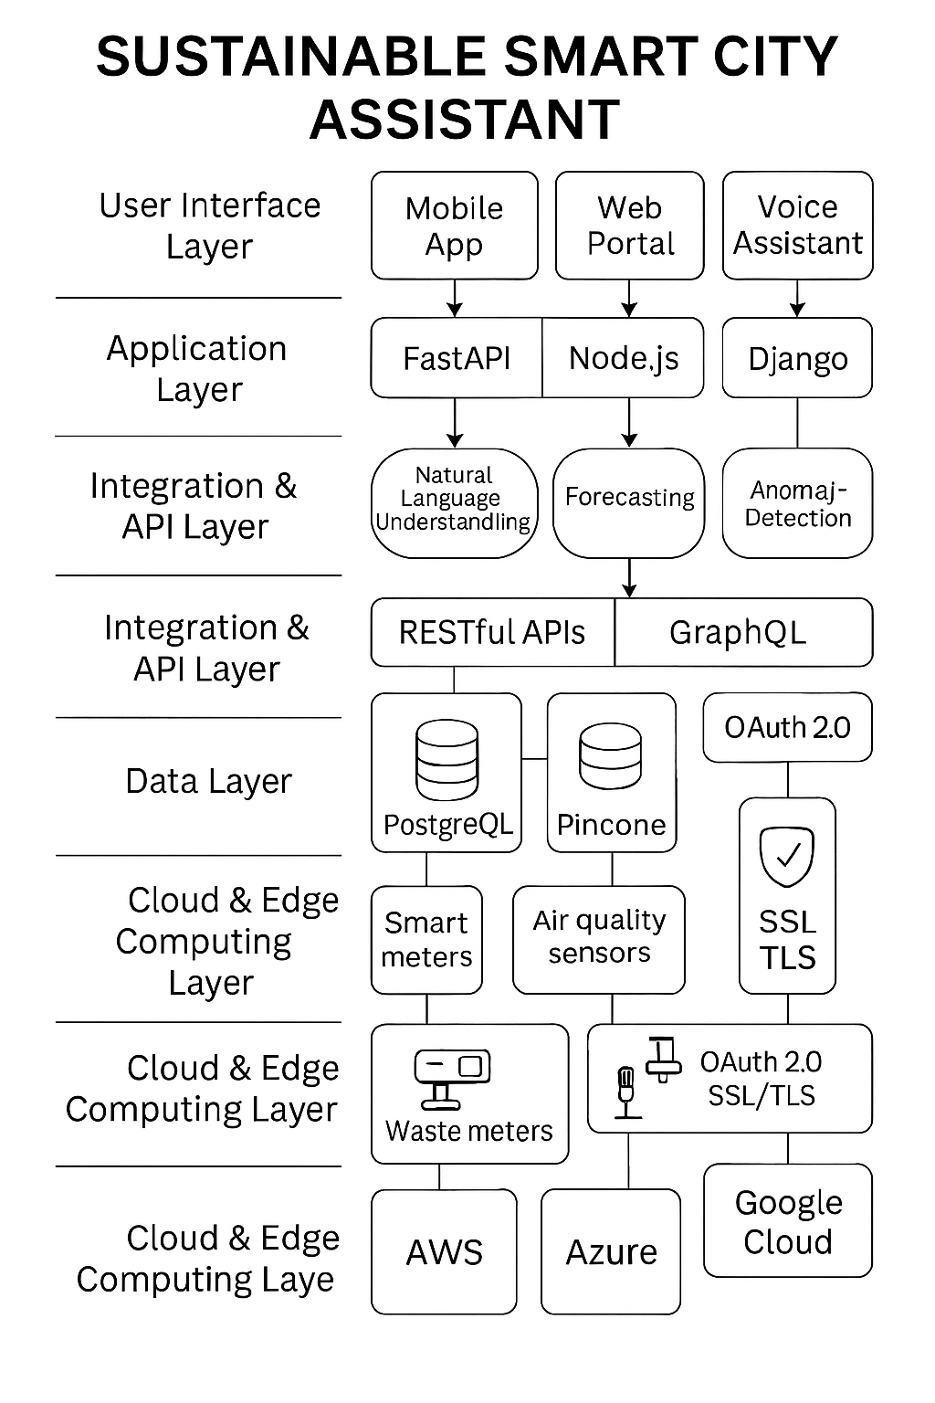

**Table-1 : Components & Technologies:**

|  |  |  |  |
| --- | --- | --- | --- |
| **S.No** | **Component** | **Description** | **Technology** |
|  | **User Interface** | Web/mobile apps or chatbots for citizen interaction. | HTML, CSS, JavaScript / Angular Js / React Js etc. |
|  | **IoT Sensors** | monitoring air quality, traffic, energy, and water usage | Java / Python |
|  | **Data Infrastructure** | Logic for a process in the applicationTo build a **Sustainable Smart City Assistant**, you need a blend of key components and enabling technologies that work together to support eco-friendly urban living | IBM Watson STT service |
|  | **AI Engine** | For forecasting, anomaly detection, and natural language understanding. | IBM Watson Assistant |
|  | **APIs & Integration Layer** | To connect with city systems and third-party services.. | MySQL, NoSQL, etc. |
|  | Cloud Database | Database Service on Cloud | IBM DB2, IBM Cloudant etc. |
|  | File Storage | **Cloud storage** for documents, logs, and uploads. **Edge/local storage** for quick, temporary access near IoT devices.**Databases** for structured data like user info and sensor logs.**Vector databases** for storing AI-friendly data like document embeddings. | Services like AWS S3, Azure Blob Storage, and Google Cloud Storage are ideal for storing unstructured data like PDFs, images, and logs. They offer scalability, durability, and easy integration with AI pipelines. |
|  | External API-1 | **IBM Watsonx Granite LLM**: Powers natural language understanding and summarization. **FastAPI**: Handles backend logic and exposes RESTful endpoints. | 5G/6G Networks: Enable ultra-fast, low-latency communication between IoT devices and cloud systems. . |
|  | External API-2 | **Pinecone**: Stores and retrieves AI embeddings for semantic search.**Streamlit**: Provides the interactive user interface. | **Internet of Things (IoT)**: External sensors and devices that monitor air quality, traffic, energy, and more.**Artificial Intelligence (AI)**: External LLMs like IBM Watsonx Granite for summarization, forecasting, and citizen interaction. |
|  | Machine Learning Model | **Core Purpose**: Help cities become greener, smarter, and more citizen-friendly using AI and real-time data.**Key Components**: IoT sensors, cloud databases, AI models (like IBM Watsonx Granite), user interfaces, and secure APIs.**Technologies Used**: FastAPI, Streamlit, Pinecone, cloud storage (AWS S3, GCP), vector databases, and NLP tools.**Features**: Forecasting, anomaly detection, policy summarization, eco-tip generation, and citizen feedback.**Guidelines**: Focus on inclusivity, sustainability, data ethics, modular design, and real-time responsiveness.**Machine Learning Models**: Regression, classification, clustering, time series (LSTM), and reinforcement learning. | **Big Data Analytics**: Tools like Apache Spark or Google BigQuery to analyze massive urban datasets. |
|  | Infrastructure (Server / Cloud) | Application Deployment on Local System / Cloud  Local Server Configuration:**Edge Servers** Deployed near IoT devices for low-latency processing .  Cloud Server Configuration : AWS, Azure, or Google Cloud provide scalable compute, storage, and AI services. |  |

**Table-2: Application Characteristics:**

| **S.No** | **Characteristics** | **Description** | **Technology** |
| --- | --- | --- | --- |
|  | Open-Source Frameworks | Hugging Face Transformers For integrating AI models like IBM Watsonx Granite | Hugging Face Transformers |
|  | Security Implementations | Role-Based Access Control (RBAC) Ensures only authorized users access sensitive data. | Role-Based Access Control |
|  | Scalable Architecture | Edge + Cloud Hybrid Real-time processing at the edge, heavy lifting in the cloud | Edge + Cloud Hybrid |
|  | Availability | Redundancy Backup systems for critical services like citizen feedback and anomaly alerts. | Redundancy |
|  | Performance | Optimized AI Models Use quantized or distilled models for faster inference. | Redundancy |